

First Semester 2024/2025
Digital Systems ENCS12340
ALU Verilog project

Fadi Ziadeh 1232120

Bitwise OR(BOR) :
Bitwise OR is a logical operation that compares corresponding bits of two binary numbers and outputs 1 if at least one of the bits is 1, otherwise outputs 0. It is commonly used in programming and digital circuits for setting specific bits in data, combining flags, or enabling features.
Verilog code:
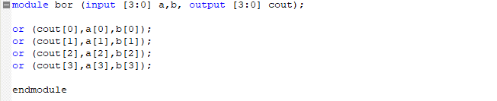
Verilog Simulation Report:
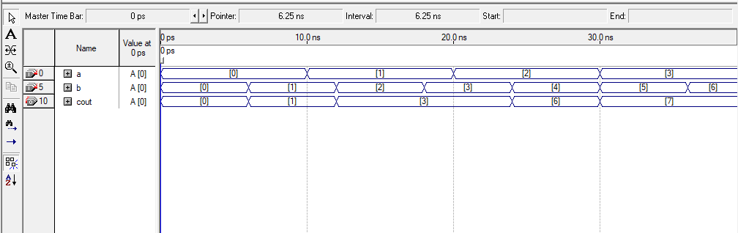

Block Diagram:
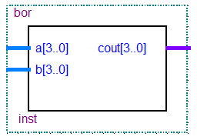
Bitwise And (BAND) :
Bitwise AND is a logical operation that compares corresponding bits of two binary numbers and outputs 1 only if both bits are 1, otherwise outputs 0. It is commonly used in programming and digital systems for masking specific bits, clearing bits, or performing bit-level filtering.
Verilog code:
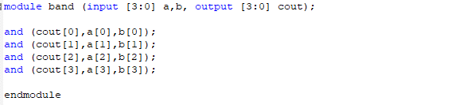
Verilog Simulation Report:
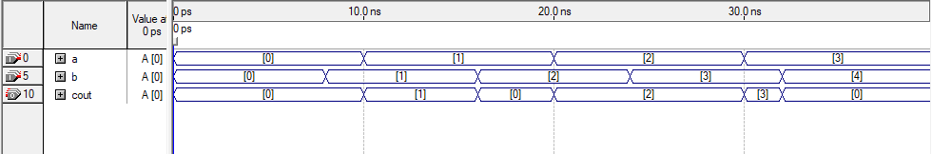
Block Diagram:
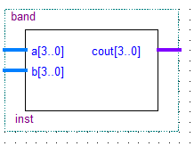

Full Adder (FA) :
A 4-bit Bitwise OR operation takes two 4-bit inputs (A0-A3 and BO-B3) and produces a 4-bit output (Cout). For each bit position, the operation compares the corresponding bits of the two inputs. If both bits are O, the output for that position is 0; otherwise, it is 1. This process is repeated for all bit positions, resulting in the final output.
Verilog code:
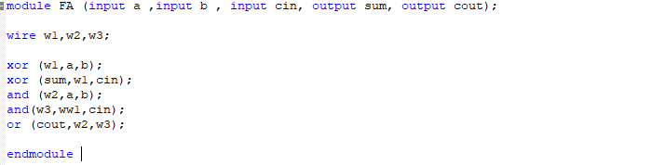
Verilog wave (Simulation Report) :
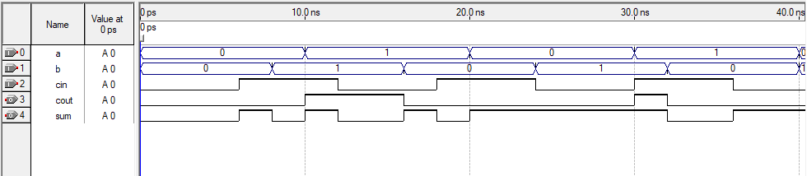

Block Diagram:
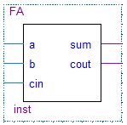

Subtractor (sub) :
A subtractor is a digital circuit used to perform subtraction between two binary numbers. It can be classified into half subtractors, which handle single-bit subtraction without borrow input, and full subtractors, which handle multi-bit subtraction with a borrow input. Subtractors are essential in arithmetic logic units (ALUs) and are often implemented using adders with 2's complement to simplify design.
Verliog code:
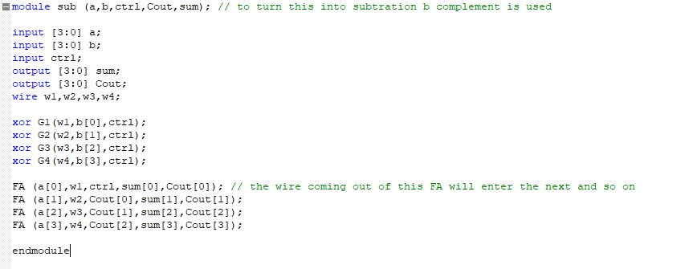
Simulation Report :
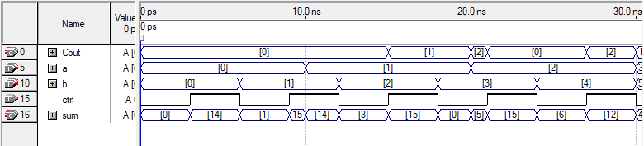
Sub Block:
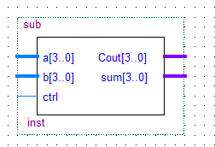
Addition (add) :
A 4-bit addition operation takes two 4-bit inputs (A0–A3 and B0–B3) and produces a 4-bit output (Sum) along with a carry-out (Cout) signal. The operation adds the corresponding bits of the two inputs along with any carry-in from the previous bit position. This process is repeated for all bit positions, propagating the carry and generating the final sum output.
Verilog code:
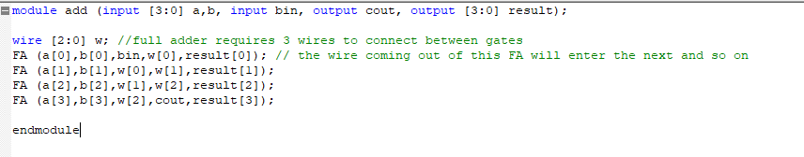
Simulation report wave:
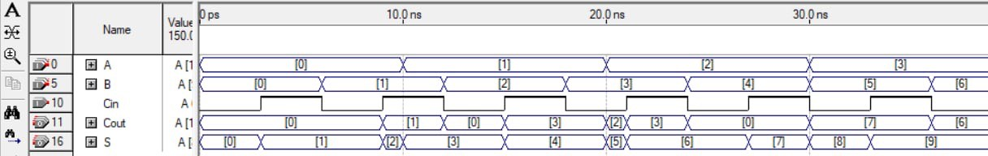

Code Block Diagram:
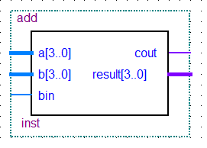

Behavioral ALU:
Arithmetic Logic Unit (ALU) : is a combinational digital circuit that performs arithmetic and bitwise operations on integer binary numbers. This is in contrast to a floating-point unit (FPU), which operates on floating point numbers. An ALU is a fundamental building block of many types of computing circuits, including the central processing unit (CPU) of computers, FPUs, and graphics processing units (GPUs). A single CPU, FPU or GPU may contain multiple ALUs.
Verilog code:
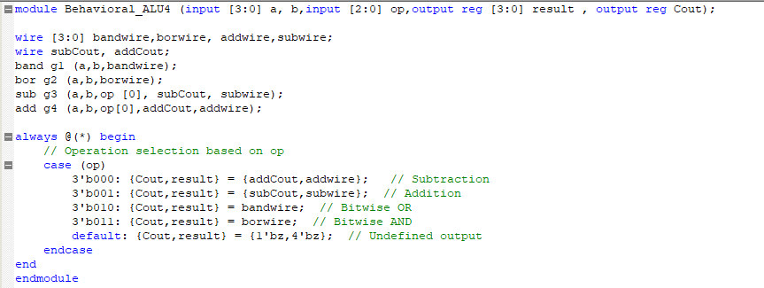
Simulation Report:
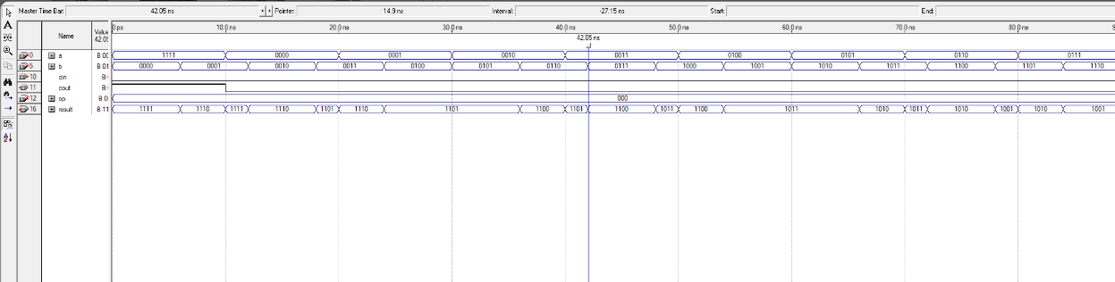
Block Diagram:
